import pandas as pd
import numpy as np
import seaborn as sns
import matplotlib.pyplot as plt
import warnings
warnings.filterwarnings(action="ignore")
from sklearn.model_selection import train_test_split
from sklearn.metrics import accuracy_score, classification_report
from sklearn.ensemble import AdaBoostClassifier
from sklearn.neural_network import BernoulliRBM
from sklearn.preprocessing import StandardScaler
from imblearn.over_sampling import SMOTE
import tensorflow as tf
from tensorflow.keras.models import Sequential
from tensorflow.keras.layers import Dense
from sklearn.metrics import roc_curve, auc
from sklearn import metrics
from sklearn.metrics import confusion_matrix
from sklearn.datasets import make_classification
from sklearn.metrics import accuracy_score, precision_score, recall_score, f1_score
C:\Users\agarw\anaconda3\lib\site-packages\scipy\__init__.py:146: UserWarning: A NumPy version >=1.16.5 and <1.23.0 is required for this version of SciPy (detected version 1.26.2
warnings.warn(f"A NumPy version >={np_minversion} and <{np_maxversion}"
#importing data from the dataset
df = pd.read_csv(r"C:\Users\agarw\OneDrive\Desktop\Dissertation\data.csv")
#checking for bankrupt companies 0 is non-bankrupt and 1 is bankrupt
bankrupt_data = df['Bankrupt?'].value_counts()
bankrupt_data
Bankrupt?
0 6599
1 220
Name: count, dtype: int64
#Distribution representation
plt.figure(figsize = (10,5))
colors = ["#3498db", "#e74c3c"]
ax = sns.countplot(x=df['Bankrupt?'], data=df,palette=colors)
for p in ax.patches:
ax.annotate(f'{p.get_height()}', (p.get_x() + p.get_width() / 2., p.get_height()),
ha='center', va='center', xytext=(0, 10), textcoords='offset points')
# Add labels and title
plt.xlabel('Bankrupt')
plt.ylabel('Count')
plt.title('Distribution of Bankrupt')
# Show the plot
plt.show()
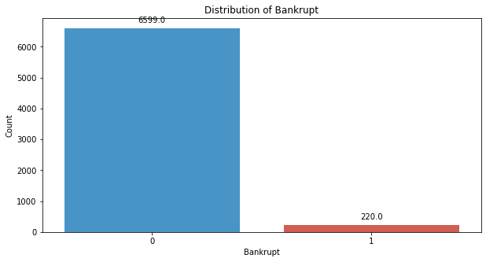
# seperate the Bankrupt label from the dataset
y = df['Bankrupt?']
X = df.drop(['Bankrupt?'], axis = 1)
# divinding our dataset into training dataset
X_train, X_temp, y_train, y_temp = train_test_split(X, y, test_size=0.2, random_state=42)
#Distribution representation
plt.figure(figsize = (10,5))
colors = ["#3498db", "#e74c3c"]
ax = sns.countplot(x=y_train, data=df,palette=colors)
for p in ax.patches:
ax.annotate(f'{p.get_height()}', (p.get_x() + p.get_width() / 2., p.get_height()),
ha='center', va='center', xytext=(0, 10), textcoords='offset points')
# Add labels and title
plt.xlabel('Bankrupt')
plt.ylabel('Count')
plt.title('Distribution of Bankrupt')
# Show the plot
plt.show()
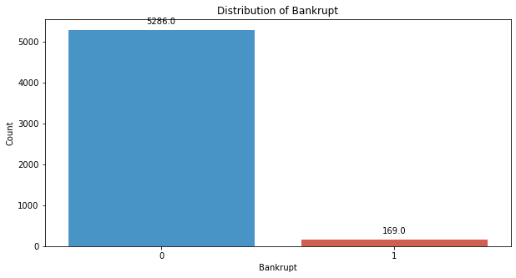
# divinding our dataset into testing and validation
X_val, X_test, y_val, y_test = train_test_split(X_temp, y_temp, test_size=0.5, random_state=42)
# Standardize the data
scaler = StandardScaler()
X_train = scaler.fit_transform(X_train)
X_val = scaler.transform(X_val)
X_test = scaler.transform(X_test)
model = tf.keras.Sequential([
tf.keras.layers.Input(shape=(X_train.shape[1],)),
tf.keras.layers.Dense(64, activation='relu'),
tf.keras.layers.Dense(32, activation='relu'),
tf.keras.layers.Dense(1, activation='sigmoid')
])
model.compile(optimizer='adam', loss='binary_crossentropy', metrics=['accuracy'])
np.shape(X_train)
(5455, 95)
np.shape(y_train)
(5455,)
model.fit(X_train, y_train, epochs=40, batch_size=32, verbose=2)
Epoch 1/40
171/171 - 1s - 5ms/step - accuracy: 0.9388 - loss: 0.2278
Epoch 2/40
171/171 - 0s - 838us/step - accuracy: 0.9685 - loss: 0.1040
Epoch 3/40
171/171 - 0s - 795us/step - accuracy: 0.9698 - loss: 0.0866
Epoch 4/40
171/171 - 0s - 814us/step - accuracy: 0.9712 - loss: 0.0787
Epoch 5/40
171/171 - 0s - 820us/step - accuracy: 0.9721 - loss: 0.0736
Epoch 6/40
171/171 - 0s - 830us/step - accuracy: 0.9751 - loss: 0.0679
Epoch 7/40
171/171 - 0s - 858us/step - accuracy: 0.9751 - loss: 0.0646
Epoch 8/40
171/171 - 0s - 790us/step - accuracy: 0.9767 - loss: 0.0619
Epoch 9/40
171/171 - 0s - 826us/step - accuracy: 0.9773 - loss: 0.0585
Epoch 10/40
171/171 - 0s - 797us/step - accuracy: 0.9795 - loss: 0.0563
Epoch 11/40
171/171 - 0s - 939us/step - accuracy: 0.9797 - loss: 0.0521
Epoch 12/40
171/171 - 0s - 938us/step - accuracy: 0.9793 - loss: 0.0487
Epoch 13/40
171/171 - 0s - 939us/step - accuracy: 0.9808 - loss: 0.0465
Epoch 14/40
171/171 - 0s - 851us/step - accuracy: 0.9835 - loss: 0.0441
Epoch 15/40
171/171 - 0s - 795us/step - accuracy: 0.9841 - loss: 0.0415
Epoch 16/40
171/171 - 0s - 803us/step - accuracy: 0.9863 - loss: 0.0378
Epoch 17/40
171/171 - 0s - 795us/step - accuracy: 0.9875 - loss: 0.0347
Epoch 18/40
171/171 - 0s - 798us/step - accuracy: 0.9866 - loss: 0.0329
Epoch 19/40
171/171 - 0s - 809us/step - accuracy: 0.9883 - loss: 0.0321
Epoch 20/40
171/171 - 0s - 813us/step - accuracy: 0.9886 - loss: 0.0301
Epoch 21/40
171/171 - 0s - 846us/step - accuracy: 0.9890 - loss: 0.0274
Epoch 22/40
171/171 - 0s - 835us/step - accuracy: 0.9903 - loss: 0.0256
Epoch 23/40
171/171 - 0s - 848us/step - accuracy: 0.9923 - loss: 0.0213
Epoch 24/40
171/171 - 0s - 917us/step - accuracy: 0.9941 - loss: 0.0193
Epoch 25/40
171/171 - 0s - 894us/step - accuracy: 0.9936 - loss: 0.0187
Epoch 26/40
171/171 - 0s - 843us/step - accuracy: 0.9945 - loss: 0.0167
Epoch 27/40
171/171 - 0s - 850us/step - accuracy: 0.9958 - loss: 0.0148
Epoch 28/40
171/171 - 0s - 990us/step - accuracy: 0.9960 - loss: 0.0136
Epoch 29/40
171/171 - 0s - 915us/step - accuracy: 0.9962 - loss: 0.0127
Epoch 30/40
171/171 - 0s - 854us/step - accuracy: 0.9973 - loss: 0.0110
Epoch 31/40
171/171 - 0s - 833us/step - accuracy: 0.9973 - loss: 0.0096
Epoch 32/40
171/171 - 0s - 826us/step - accuracy: 0.9984 - loss: 0.0094
Epoch 33/40
171/171 - 0s - 808us/step - accuracy: 0.9973 - loss: 0.0086
Epoch 34/40
171/171 - 0s - 848us/step - accuracy: 0.9980 - loss: 0.0085
Epoch 35/40
171/171 - 0s - 829us/step - accuracy: 0.9993 - loss: 0.0063
Epoch 36/40
171/171 - 0s - 832us/step - accuracy: 0.9984 - loss: 0.0068
Epoch 37/40
171/171 - 0s - 826us/step - accuracy: 0.9985 - loss: 0.0082
Epoch 38/40
171/171 - 0s - 818us/step - accuracy: 0.9987 - loss: 0.0056
Epoch 39/40
171/171 - 0s - 805us/step - accuracy: 0.9995 - loss: 0.0056
Epoch 40/40
171/171 - 0s - 809us/step - accuracy: 0.9998 - loss: 0.0035
<keras.src.callbacks.history.History at 0x1756972af10>
#Validation dataset
y_val_pred = (model.predict(X_val) > 0.5).astype(int)
22/22 ━━━━━━━━━━━━━━━━━━━━ 0s 2ms/step
# Evaluate the model's performance on the validation set
val_accuracy = accuracy_score(y_val, y_val_pred)
precision = precision_score(y_val, y_val_pred)
recall = recall_score(y_val, y_val_pred)
f1_value = f1_score(y_val, y_val_pred)
val_report = classification_report(y_val, y_val_pred)
print("Accuracy", val_accuracy)
print("Precision", precision)
print("Recall", recall)
print("F1 Score", f1_value)
print("Validation Classification Report:\n", val_report)
Accuracy 0.9604105571847508
Precision 0.29411764705882354
Recall 0.25
F1 Score 0.27027027027027023
Validation Classification Report:
precision recall f1-score support
0 0.98 0.98 0.98 662
1 0.29 0.25 0.27 20
accuracy 0.96 682
macro avg 0.64 0.62 0.62 682
weighted avg 0.96 0.96 0.96 682
conf_matrix = confusion_matrix(y_val, y_val_pred)
print("Confusion Matrix")
print(conf_matrix)
Confusion Matrix
[[650 12]
[ 15 5]]
y_test_pred = (model.predict(X_test) > 0.5).astype(int)
22/22 ━━━━━━━━━━━━━━━━━━━━ 0s 661us/step
# Evaluate the model's performance on the test set
test_accuracy = accuracy_score(y_test, y_test_pred)
precision = precision_score(y_test, y_test_pred)
recall = recall_score(y_test, y_test_pred)
f1_value = f1_score(y_test, y_test_pred)
test_report = classification_report(y_test, y_test_pred)
print("Accuracy", test_accuracy)
print("Precision", precision)
print("Recall", recall)
print("F1 Score", f1_value)
print("Test Classification Report:\n", test_report)
Accuracy 0.9560117302052786
Precision 0.5384615384615384
Recall 0.22580645161290322
F1 Score 0.3181818181818182
Test Classification Report:
precision recall f1-score support
0 0.96 0.99 0.98 651
1 0.54 0.23 0.32 31
accuracy 0.96 682
macro avg 0.75 0.61 0.65 682
weighted avg 0.94 0.96 0.95 682
conf_matrix = confusion_matrix(y_test, y_test_pred)
print("Confusion Matrix")
print(conf_matrix)
Confusion Matrix
[[645 6]
[ 24 7]]
# Compute ROC curve and ROC area for each class
fpr_val, tpr_val, _ = roc_curve(y_val, y_val_pred)
roc_auc_val = auc(fpr_val, tpr_val)
fpr_test, tpr_test, _ = roc_curve(y_test, y_test_pred)
roc_auc_test = auc(fpr_test, tpr_test)
# Plot ROC curve
plt.figure(figsize=(8, 8))
plt.plot(fpr_val, tpr_val, color='darkorange', lw=2, label=f'Validation ROC curve (area = {roc_auc_val:.2f})')
plt.plot(fpr_test, tpr_test, color='green', lw=2, label=f'Test ROC curve (area = {roc_auc_test:.2f})')
plt.plot([0, 1], [0, 1], color='navy', lw=2, linestyle='--')
plt.xlim([0.0, 1.0])
plt.ylim([0.0, 1.05])
plt.xlabel('False Positive Rate')
plt.ylabel('True Positive Rate')
plt.title('Receiver Operating Characteristic (ROC) Curve')
plt.legend(loc="lower right")
plt.show()
